April 16, 2020

Lifestyle Intervention Olfert Research Lab

1194 Evansdale Drive

Morgantown, WV 26506

Dear Dr. Olfert:

Subject: eB4CAST Project Results

Our group is extremely excited to share our findings with you. We are very confident that our results will give your team what it needs to take your social media accounts, and promotion of non-profit businesses to the next level!

We each went to Instagram, and Twitter to view the Olfert Research Labs accounts, and noticed a few things right away. The profiles simply have a low amount of followers, and low levels of engagement. Another issue is that some posts are word heavy, leading some to scroll right by. After conducting research, we found a few examples of successful Twitter and Instagram accounts, and evaluated what they were doing to gain so many followers, likes, and shares. The team could improve the social media promotion in two ways. Through post designs, and giveaways, which we will discuss further during our project. The limitations we found were mostly on Twitter. We noticed that even the most popular health accounts do not have much engagement, even with hundreds of thousands of followers.

We hope that you find our project results, and research useful. We greatly enjoyed working with you, and we wish your team success in the future!

Sincerely,

eB4CAST Orange Team 2

Shawn Smith, Jaylan Mobley, Sean Snider, Maxwell Walney



**eB4CAST: Promoting Non-Profit on Social Media Project**

**Olfert Research Lab**

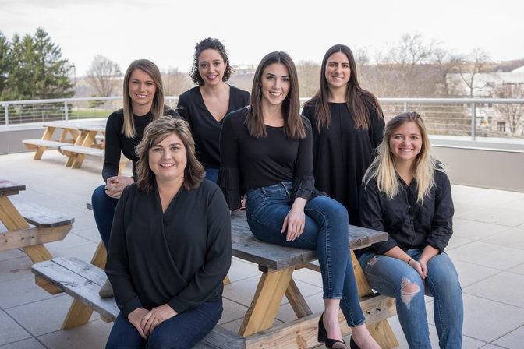

**Team Members: Shawn Smith, Maxwell Walney, Jaylan Mobley, Sean Snider**

**Table of Contents**

**Contents**

Introduction & Background……………………………………………………………..1

Research and Development……………………………………………………………..1

Primary Research……………………………………………………………………….1

Secondary Research…………………………………………………………………….2

Instagram………………………………………………………………………………..9

Recommended Instagram Post Designs………………………………………………...10

Twitter…………………………………………………………………………………...12

Twitter Posts & Related Pages…………………………………………………………. 13

Conclusion…………………………………………….................................................... 13

References……………………………………………………………………………… 14

**List of Figures**

Figure 1 Daily Active Social Media Workers……………………………………..……3

Figure 2 Social Media Users by Generation……………………………………………3

Figure 3 US Adults Social Platform……………………………………………………4

Figure 4 Percent Earned Graphic……………………………………………….……....4

Figure 5 Original Instagram Post……………………………………………………….6

Figure 6 Mental Health America Post………………………………………………….7

Figure 7 Designed Instagram Post……………………………………………………...8

Figure 8 Mental Health America Twitter Post………………………………………….9

**eB4CAST Project Introduction and Background**

Olfert Research Labs, located on the Evansdale Campus of West Virginia University, has a series of six different research projects to increase awareness across the community and offer help. This report will be on the eB4CAST project, aimed to provide support for promoting non-profit organizations. We did some research on how to increase engagement online with social media, and we assessed the current state of the Olfert Research Lab Twitter, and Instagram accounts. After viewing some other popular Twitter and Instagram accounts, we have gathered some thoughts on how to reach our goal based on what these health accounts have done to gain their popularity and social media success.

Currently, the “olfertresearchlab” Instagram and “ORLWVU” Twitter have a couple hundred followers, but we want to increase the number of likes, shares, retweets etc. We want to make this available for policy makers, researchers, and community programs. It would be great for some community-based programs to use eB4CAST in their programs, and share research findings with them. Our overall goal is to simply reach more people, so that they can engage with the page, comment, share, like, retweet, etc.

**Research and Development**

In this project, we used both primary and secondary research when it comes to developing a strategy for using social media to promote our non-profit, eB4CAST. Each section will describe how we can make the organization’s social media situation better, and how we can improve it to draw in more people and potential customers. The primary research section will describe how we analyzed the organization’s social media pages and what we could do to improve them, so we can utilize them to their absolute full potential. The secondary research will include the information we researched from previous existing studies on how to promote an organization effectively using social media platforms.

**Primary**

eB4CAST has an Instagram page and a Twitter page named, “olfertresearchlab” and“ORLWVU.” The Instagram page currently has: 47 posts, 204 followers, and following 808 accounts. The Twitter page currently has: 205 tweets, 122 followers, and following 486 accounts. There are a couple areas of interest that we would like to improve when it comes to this Instagram page and Twitter page. We want to make better posts that get more likes and views, also make the posts easier to view and understand. We also want to fix the followers to following ratio as well. Research shows that posts with nice pictures and short captions that are to the point, get more likes and views on the post. We also want to go through the list of accounts that eB4CAST follows and unfollow all the unnecessary accounts.

**Secondary**

The secondary research comes from existing research studies on how an organization can use social media to promote their business. This research section is split up into three parts that are all critical to successfully promoting the non-profit organization on social media. The sections are: The importance of social media to non-profits with building a community and fundraising, using social technology to make business decisions, and using advertisement to get closer with the customers and the impact of events on social media.

Social media is very important to non-profit organizations, not only for raising money and getting their cause out to the public, but it is also important to build a community for your cause. No matter how big or how small your organization is, social media is a great way to build relationships and be able to connect with them at any time. That connection needs to be quick because news can come at any time and having the community up to date is the best thing you can do for your organization. There are about 3.5 billion users on social media in the world (Baer 1), even though all of those users will not be a part of your community, you can expand your community and spread your message farther than what was originally intended for. Social media websites are the most used websites in the world, so you have a better chance of expanding your community and spreading your word to people that may have not heard of your organization or your message. Once you have a good idea of your community, there are three main elements to keeping your community and building upon it. You have to build trust in your community, and a good way to build that trust is to listen to your community. Engage their interactions and consider their suggestions. Share your data that you produce to the community, do not keep anything a secret and be willing to serve your community as well. All these things can build that initial trust between the organization and its community, established people and new ones you are trying to reach. 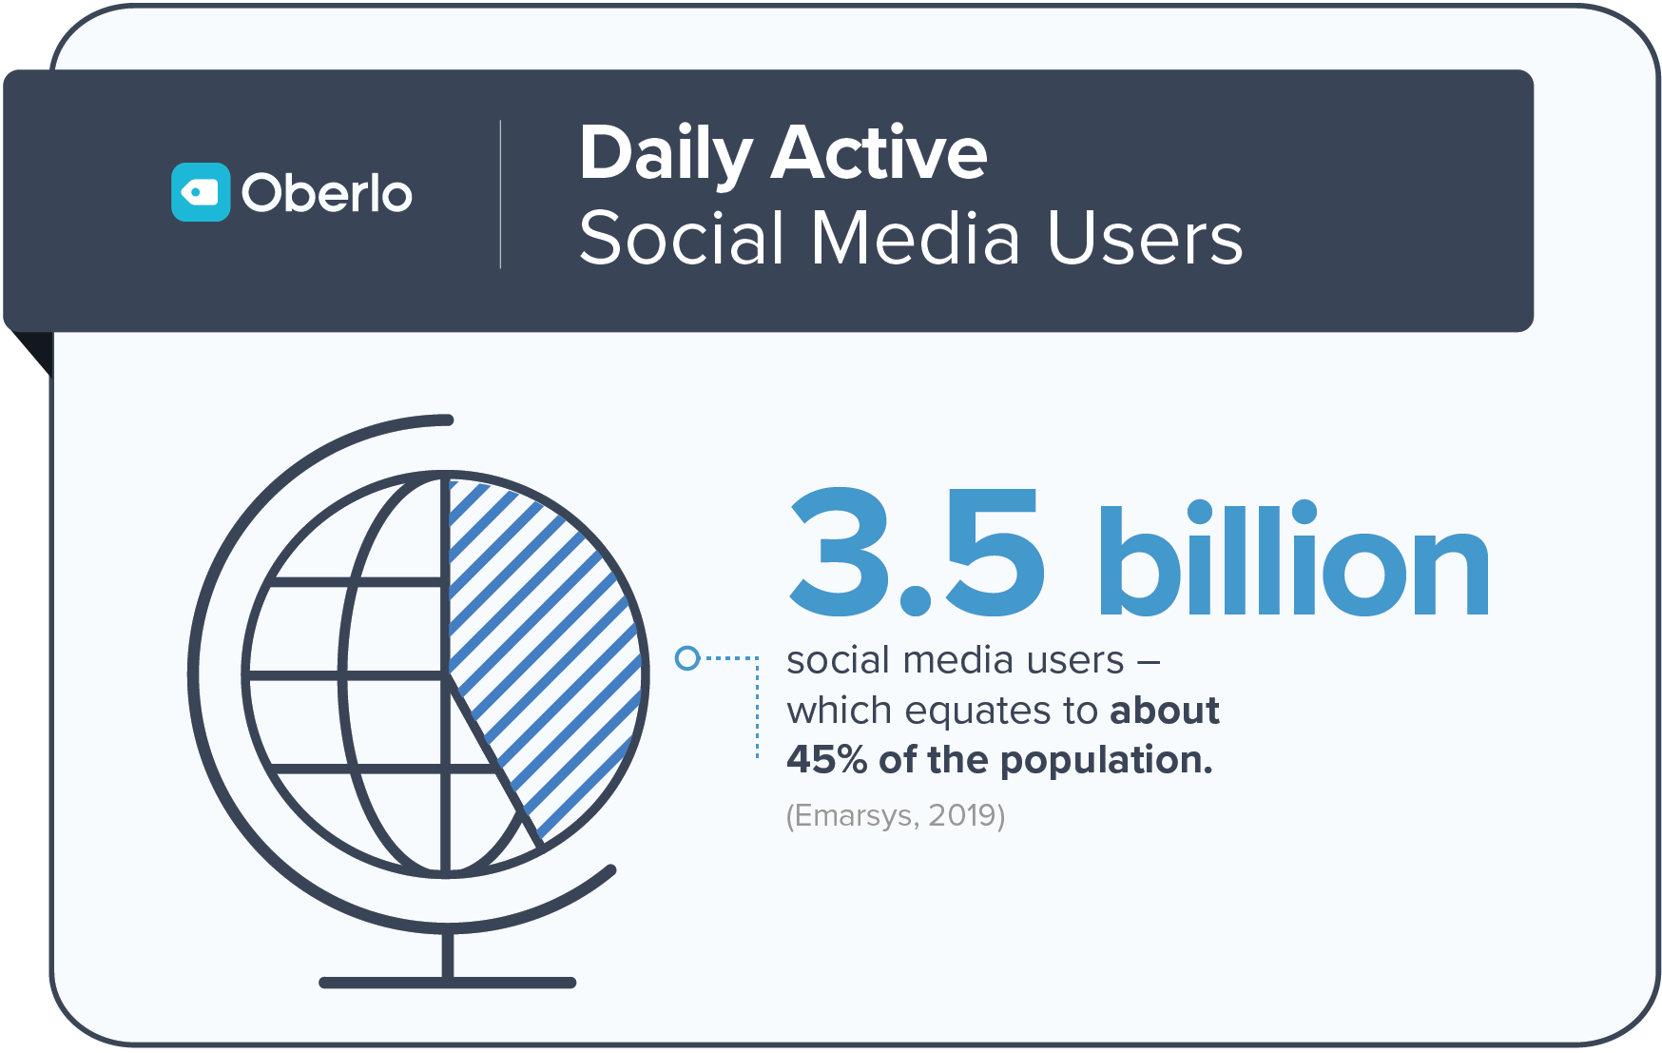

**Figure 1**

Next, you have to be organized and plan things out before going forth and doing them. You want to practice what your mission is, so planning events or organizing a schedule for when goals should be achieved will show your community that you are serious about your cause. Finally, you want to use the same language across all channels. Make sure you speak the same language as your community as well as the targeted community. Also, use the same tone across each channel or different social media platforms, so you do not confuse your community. Knowing your community, for example the number of certain people from different age groups and ethnicities, and following these elements, will make it easier to keep and grow your community. 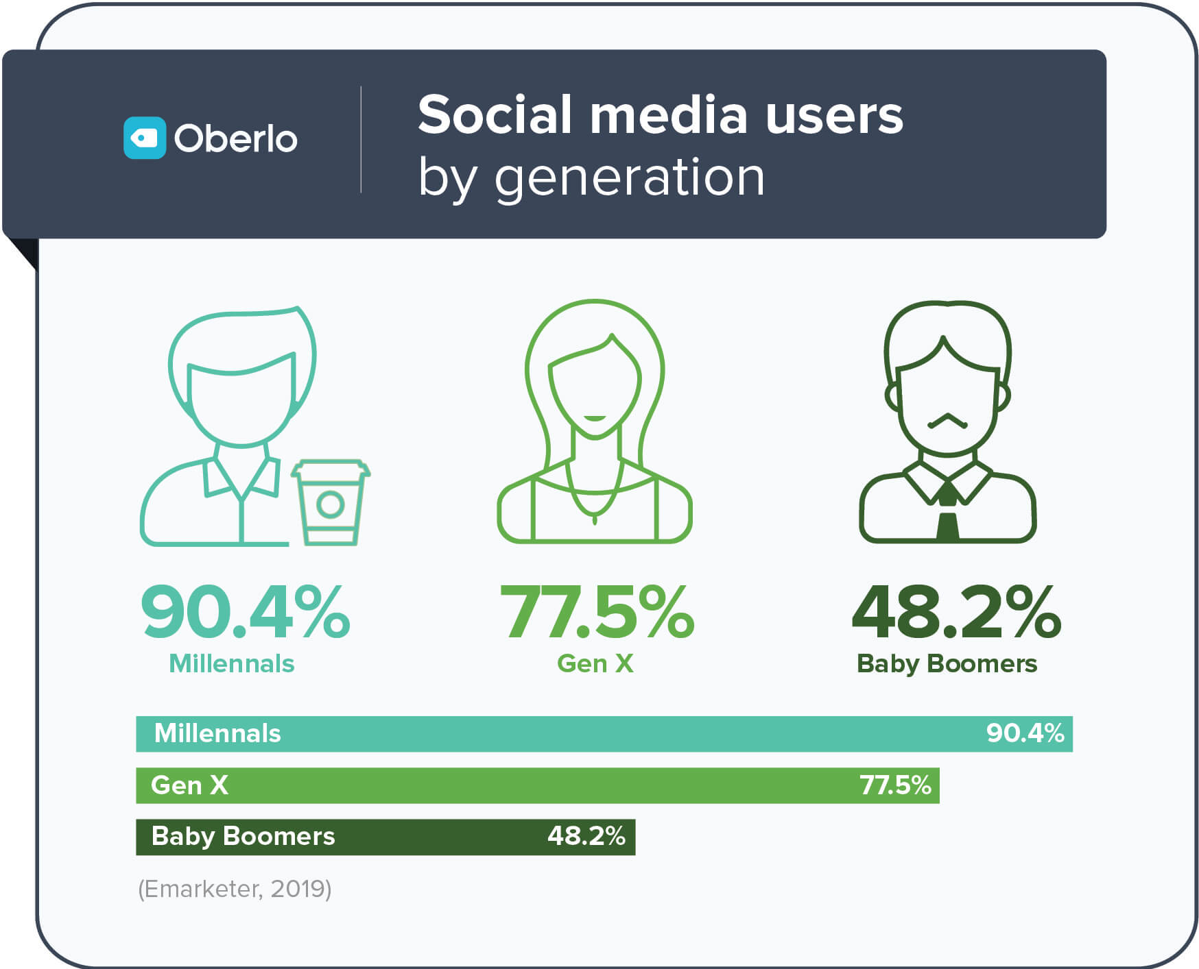

**Figure 2**

**Figure 3**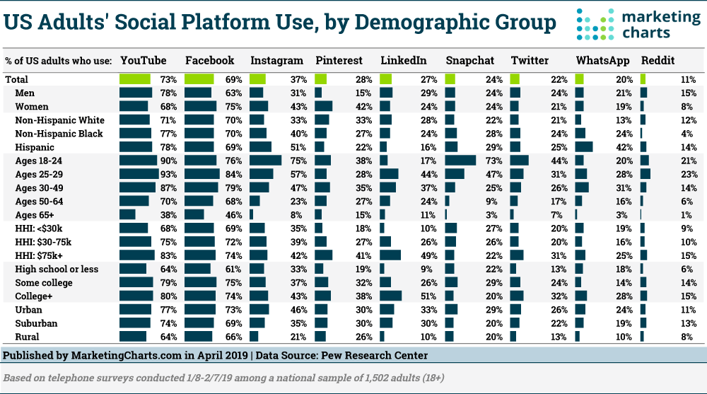

The most important thing to a non-profit organization's goal of raising awareness for their cause, besides building the community, is getting funds to achieve their goal. Fundraising for the organization is the main source of revenue, for example, selling shirts, holding money-raising events, and having monthly subscriptions. This is called private fees for services and it brings in almost 50% of the revenue for the organization (Hrywna 1). The government supports non-profit organizations, but it all depends on the size and the mission of the organization. This is where organizations can take advantage of social media. Not only can they get more money from their community, but they can grow their community to the point that the government can see the cause is legitimate and get them to grant the organization more money. Social media is important for not only fundraising but growing the mission’s popularity to receive more revenue. 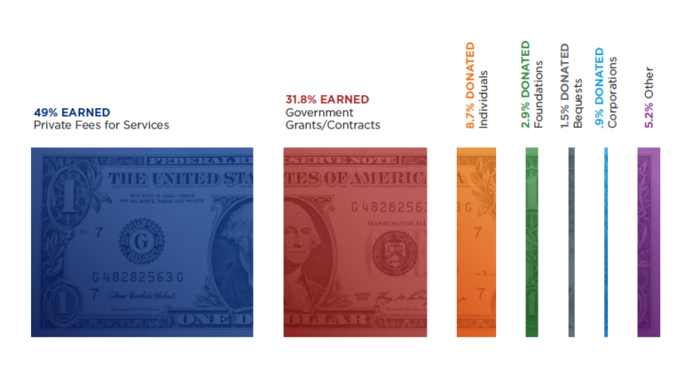

Figure 4

Even though eB4CAST is considered a lab and not a business, it still needs money to run. So, here are some suggestions on how to make money for the lab. Moving on from raising money and building the community, the organization is still a business, with a business comes business decisions. The organization’s priorities have to be in order, and the customer experience has to be at the top of that list. Then, focusing on things that actually matter to your mission. Social media and its technology can help make these tasks easier and less time consuming. A business wants to do three different things to be successful: sell things, save money, and be innovative. Using social media can help boost sales, save money, and get new ideas on what to do next. If your organization wants to sell new merchandise or subscriptions to make money, posting on social media can boost the sales because more people will see it. Posting your new merchandise on a social page can save money as well, you do not have to pay that much for advertisement or to have your merchandise in a store. Those fees will disappear which will increase your profit. The organization can also post polls or have discussion groups to see what the community says about new ideas. All these strategies can be done with social media across all platforms.

There are two sides of social media, the side you can control and the side that is out of your control. As an organization leader this may seem confusing at first, but it is actually very easy to comprehend. The side you control is the organization’s social media accounts and the posts that get made for the account. Putting ideas, and data out there for your community to see can be very useful. The side you cannot control is the popularity and views that the post gets. It is up to you to make a great post that people will like and share. Once they share it, it may come across other people that are not involved in your community yet. This idea can be put into the same perspective when it comes to events that the organization holds. Getting new people there is very important, so posting to social media about the event is the best way to approach that. Events can help people see others who follow the same mission as them, also see who is running the organization as well. This will grow a bond and trust, the word must get out, that is where social media can help the organization tremendously.

The primary and secondary research we have done will help not only promote eB4CAST’s mission, but help their organization grow their community. Growing the community will bring in more revenue for their mission, but also help spread the word on what their mission is and what it does. Promoting on social media will be the best option for them to accomplish these goals for the mission and organization as a whole.

**Instagram Posts**

Currently, the eB4CAST project does not have its own page. Instead, Olfert Research Labs has the page so that it posts content from each project collectively. The account currently has a lot of great things including pictures of the members working on these projects, new information, and helpful tips about health. In order to achieve the goal of increasing engagement, whether that means likes, shares, or comments, the Instagram posts should include a few things.

First, some of the current posts have heavy content on the picture. Although some may read the majority of it, this sometimes makes people scroll right by it. The page includes so many great images and designs and could incorporate more posts with less words that will catch the person's eye. A great way to do that is by posting a link in the pages bio to the information being discussed in the post and directing the reader to follow the link for more information regarding that post, while having a much more condensed and reader friendly version of the information on the post just to pique the reader’s interest and grab attention. Another way to reduce heavy content on the picture is to type some of the information in the caption so that the user can easily read it rather than having to read solely from the graphic. This is one of the posts on the page below. It includes great images but would be somewhat hard to read.

When focusing on increasing followers, a great strategy to do this could be doing a contest. This could be something such as, like this post, and tag a friend in the comments for a chance to win a gift card, or things such as WVU football tickets.

**Figure 5**

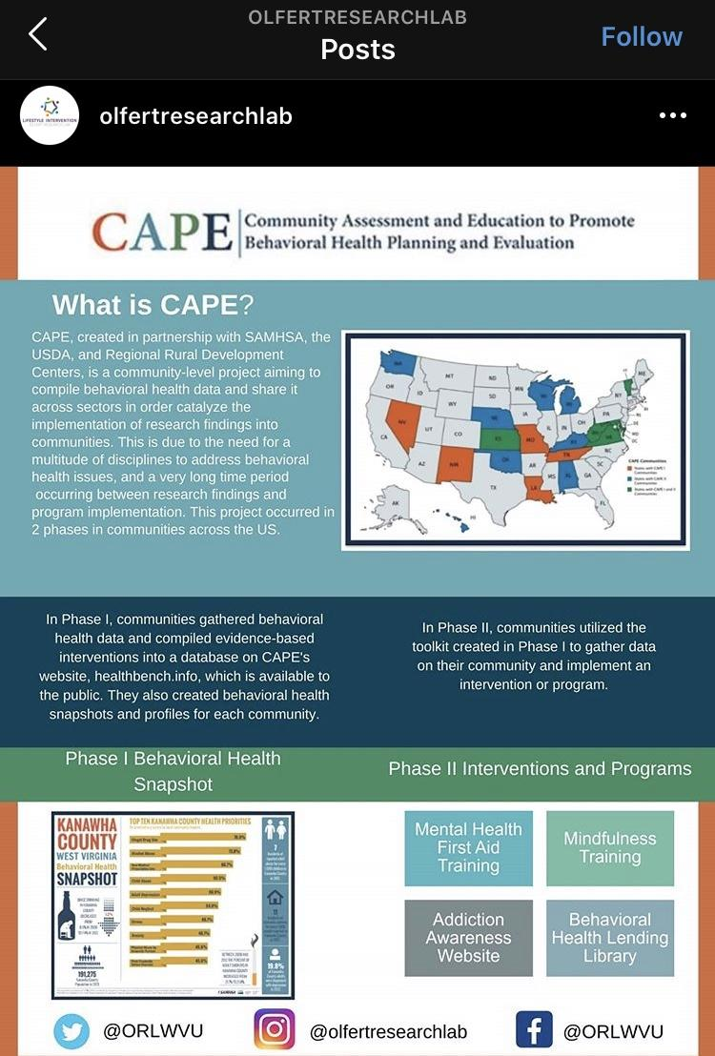

We began to look as a group at some of the popular Instagram health accounts, to see what they were doing to gain followers, likes, and success. A good page we found which was comparable was “mentalhealthamerica” and they currently have 107k Instagram followers. They tend to post things such as positive messages about the COVID-19 crisis, to new podcasts and articles they are releasing. If Olfert Research Labs is releasing new articles, projects, or news, a post similar to this would be perfect. Simply posting a small statement on the picture, catches the eye. Putting the majority of the information either in the caption or in a separate link would be perfect in order to have users engage with it.

**Figure 6**

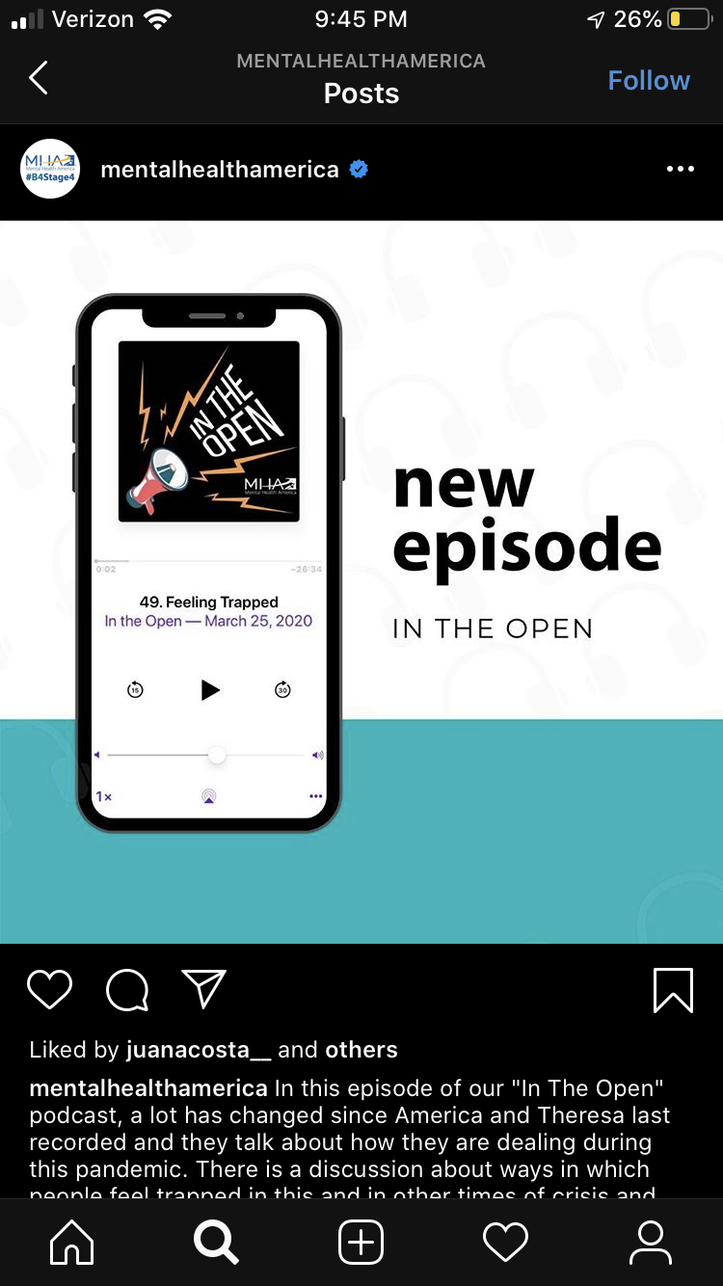

In an attempt to make our own post that we believe would be most appealing and would get people to engage more would be something like the image below. This both encourages the reader to read the content and interact with the post. There is not an overwhelming amount of words or content on the image. This will hopefully prevent people from scrolling right by on their feed.

**Figure 7**



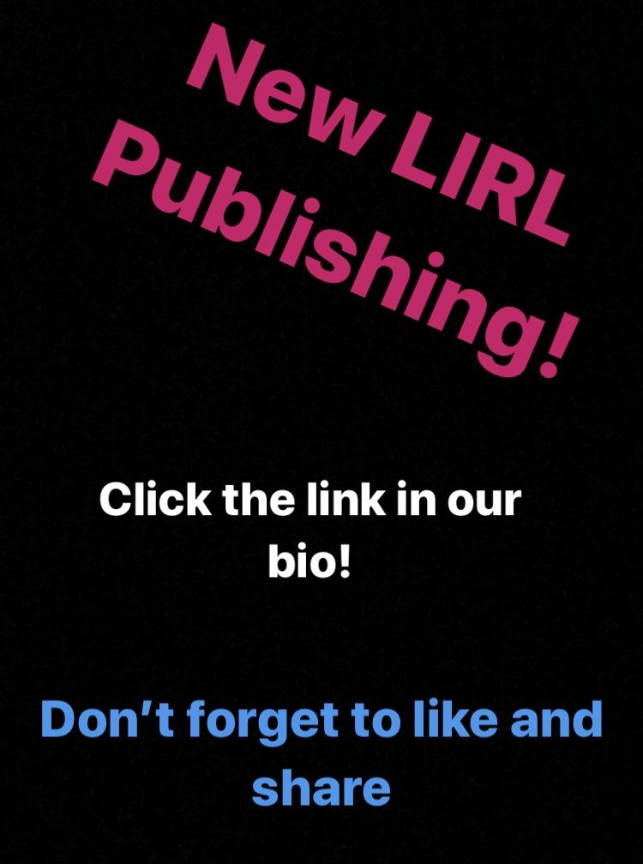

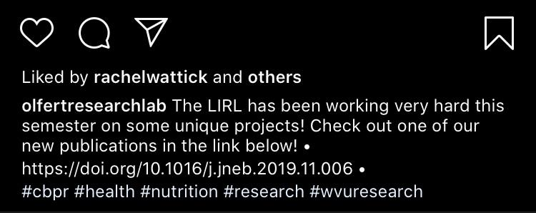

**Twitter Posts**

The main issue with the @ORLWVU Twitter page is that there is simply a very low amount of followers, and a miniscule amount of likes or retweets, and this is something to fix. The page has 122 followers, and most of the tweets have no likes or retweets as of recently. Some ways this page can grow is follow more people, and attempt to get the amount of followers up. Encourage followers to like, retweet, or even give the account a shoutout if they enjoy it or find it helpful. Another thing the account could do is share content from others. This is a great way to attract other users. Because this is a WVU organization, and most people that follow it are staff or students, retweeting or liking posts that are WVU related would also attract more people.

Another possibility to gain a good number of followers in a relatively short period of time is to have a small giveaway. The giveaway could consist of three WVU t-shirts, and to enter users would simply have to retweet the giveaway and follow @ORLWVU. To help increase the reach of this giveaway, we would ask that @WestVirginiaU (currently at 186.1k followers) and @WVUHealth (currently at 2,901 followers) would retweet our giveaway as well and encourage their followers to follow us. After one week from the original giveaway post, three users who retweeted and followed the account would be randomly selected to win a t-shirt. This is a very inexpensive and quick way to increase the twitter following for the account and would benefit greatly from the WVU and WVU Health accounts encouraging participation from their combined following of almost 190k followers. 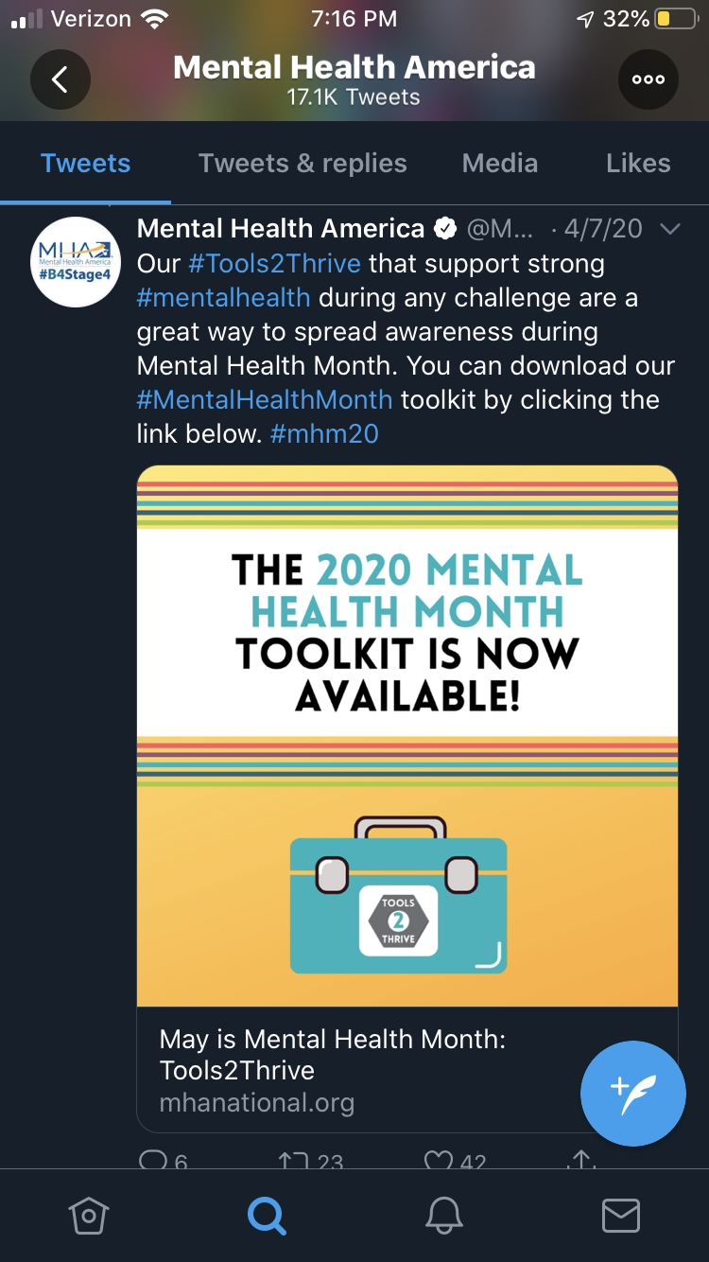

**Figure 8**

Twitter allows the profile to attach links onto the post itself, like the image to the right. This image is from @MentalHealthAm which has 338k followers. They keep their tweets brief, and informative. They retweet from other related pages that post positive messages, and although the page has three hundred thousand followers, there seems to be one common theme with these popular health pages. There is still very low amounts of engagement; no matter how many people follow the page. The @MentalHealthAm page averages anywhere from 5-20 likes, and 1-4 retweets.

**Conclusion**

Non-profit organizations focus daily on different ways to engage the audience on social media. Research shows that building a platform by using social media is a very powerful way to succeed as a non-profit organization. The eB4CAST project is focused on providing support for promoting non-profit organizations. We researched with the intent-based on, “how to increase engagement online with social media”. We were successful by conducting research and development along with implementing strategies that would have a positive effect on their social media engagement. These strategies helped us to research and understand different research strategies such as primary and secondary research. By having primary and secondary research, Instagram and Twitter became our main interest in gaining the most audience engagement for the organization. On the other hand, we were able to take a look into eB4CAST social media and focus on their activity to see causes for inactive engagement. This allowed us to analyze data and compare facts that could best help the organization. Also, by comparing facts and analyzing data from other non-profit organizations, it helped us give insight into what works versus doesn't work. With research and analysis, we look forward to seeing how our information will affect their social media engagement and outreach!

**References**

Baer, Jay. “Social Media Usage Statistics for 2019 Reveal Surprising Shifts.” *Content Marketing Consulting and Social Media Strategy*, 2019, <https://www.convinceandconvert.com/social-media-research/social-media-usage-statistics/>

Evans, Dan, and Joe Cothrel. “Social Customer Experience : Engage and Retain Customers through Social Media.” *West Virginia University Libraries*, Sybex, Apr. 2014, <https://libwvu.on.worldcat.org/oclc/880677893>

Hrywna, Mark. “80% Of Nonprofits' Revenue Is From Government, Fee For Service.” *The NonProfit Times*, 19 Sept. 2019, <https://www.thenonprofittimes.com/news/80-of-nonprofits-revenue-is-from-government-fee-for-service/>

Kapin, Allyson, and Amy Ward. “Change Anytime Everywhere : How to Implement Online Multichannel Strategies to Spark Advocacy.” *West Virginia University Libraries* , John Wiley, 11 Feb. 2013, <https://libwvu.on.worldcat.org/oclc/829460558>

Mohsin, Maryam. “10 Social Media Statistics You Need to Know in 2020.” *Oberlo*, 23 Mar. 2020, <https://www.oberlo.com/blog/social-media-marketing-statistics>

Paine, Katie Delahaye. “Measure What Matters : Online Tools for Understanding Customers.” *West Virginia University Libraries*, Wiley, Mar. 2011, <https://libwvu.on.worldcat.org/oclc/669262744>

“Social Networking Platforms' User Demographics Update 2019.” *Marketing Charts*, 22 Apr. 2019, <https://www.marketingcharts.com/digital/social-media-108184>

“Instagram logo”and “Twitter logo, March, 2020, <https://www.nytimes.com>

“Have a great day image”, May 2019, https://www.birthdaywishes.expert.com

“Let's go mountaineers image” December 2019, www.business.facebook.com

“Question mark image”, August 2018, www.blogs.edweek.org