**GLO-BUS Simulation Report**

**Spring 2021**

**Section number & time__C03 1:00pm**

**Prepared by Team** F

Timothy Arch

Matthew Volpe

Sean Snider

Jackson Wenig

Total points your team got in the simulation: 82

Final ranking of your team in the simulation: 6

Contents

**1.** **Company Information** 3

**2.** **Strategic Choices and Their Implementation** 3

**3.** **Analysis of the External Environment** 4

**4.** **Analysis of the Internal Environment** 4

**5.** **Conclusion** 5

**6.** **Insights** 5

**APPENDICES** 5

Appendix A “Our Company’s Strategy Canvas Over Time” 6

Appendix B “Strategic Canvas: Comparison with Competitors” 7

Appendix C – “Porter’s Five Forces” 8

Appendix D “PESTEL Analysis” 9

Appendix E “Strategic Groups Map” 10

Appendix F “Value Chain” 11

Appendix G “Performance Analysis: Comparison with Competitors” 12

Appendix H “SWOT Analysis” 13

**REFERENCES** 13

**GLO-BUS report evaluation rubric** 14

# **Company Information**

Falcon Drones was founded years ago as a small startup in the drone and camera industry. At Falcon Drones our vision is simple: enable users to see the world from a breathtaking new

perspective. Our goal is to grant users a unique ability to capture breathtaking views in the best quality possible.

For this reason, we are utilizing a differentiation strategy at Falcon Drones by offering differently priced models based on the users’ needs, crafting our products with high quality materials built to withstand diverse conditions, and backing our products with warranties. This is a good approach for our company because it sets us apart for competitors, while still appealing to a large number of consumers due to our different models that accommodate almost all price points.

**2. Strategic Choices and Their Implementation**

1. The product scope we were going for was to be the best quality drone producer at a respectable price, we made our cameras with average parts and a mid price range. Our diversification strategy was to have a related product as described by Rumelt’s topology. We used the same camera we were making in the AC camera market but upgrading it significantly in the drone housing. This is how we tied in the topology. With every other component on the drone we made them significant upgrades or just the highest option available. Our vertical scope was to make everything in house that way we cut down on costs and knew our product had good quality parts. The geographic scope of our company was over several regions: North America, Europe-Africa, Asia-Pacific, and Latin America. The type of globalization strategy that we implemented was to adhere to the customer spending habits.

Customers in Latin America and Asia-Pacific would only pay costs that were lower than North America and the Europe-Africa Region because they had less spending power, stated by the camera and drone journal. North America and Europe-Africa were our most profitable markets because they had the ability to spend a higher amount for the drone and camera than the other regions. Thus we made more money in these regions because of this. We made 35% operating profit margin in NA and 32.4% in EA because we could charge higher prices and thus offset our assembly costs.

1. We chose to go with a differentiation strategic position rather than cost because we wanted to stand out as the company with the best luxury drones on the market with great costs. We decided to do this because we knew we were going to lose money in the beginning because we were barely charging enough to stay profitable with the drone to have spending money but we thought if we had the best drone but at similar prices as the other companies than eventually we would have all the customer base buying from us after marketing and advertising the drone thus giving us a monopoly in this industry.

Our strategy did change around year 9 because it seemed like we were loosing market share in this industry and spending too much money on the drones, it also seemed that only what we did to the camera market affected our demand and profitability so in the end we switched to the cameras being the best product we sold and then sold a intermediate drone. It seems it was not a good strategy as the book claims you need to have a promising strategy from the beginning that starts with a clear and critical diagnosis of the competitive challenge. We quickly found out however that our initial strategy was our best strategy to continue doing business so we reverted back. Losses are common but should be conquered a few years into business.

1. As stated above our company decided to do all of our product design in the 1st decision round. So we gave the camera intermediate components, such as we scrolled halfway through the list of options in each aspect and went with that. That way our camera wouldn’t be blown out of the water by other companies maxing them out. We then maxed out our drone with the best of everything (significant upgrades to the camera, best battery life, rotors, advanced flight controller etc.) We chose to do this because we wanted to stand out from the competition (differentiation strategy) .

We didn’t touch anything else the 1st year. On the next decision round we went crazy into marketing so that we could get more market share and demand as well as our product name out there. From there on we tweaked the price here and there to keep up with investor expectations and return on equity requirements. The other aspects we deemed important and consistently increased was Compensation and facilities and corporate citizenship. In compensation and facilities we annually increased the base wage for our workers to keep them happy and incentivized staying with the company and wanting to come to work and make profits. We also kept expanding our workstations so that no one had to work overtime and thus keep the morale of the workers high since high moral = high productivity.

In corporate citizenship we decided to donate 4% of our operating profits to charity and invested in a renewable energy program. We also improved working conditions by adding a cafeteria on site and onsite child care facilities for the workers as well as additional safety equipment, ventilation, and lighting in the facilities. We did this to increase our image rating each year and also keep our workers happy.

Our strategy changed to our rivals because we had to adjust our pricing to avoid under charging ourselves and thus being less competitive and profitable. We also had to increase our stock prices that way investors would be very interested in buying our stock and trading it on the open market.

If you would like to see the raw data of our decisions and how we compared to the competitors check out appendices A and B which show our strategic canvas for our years of operation.

# **3. Analysis of the External Environment**

1. In the market of wearable cameras and camera drones, profitability potential is limitless. The wearable camera market is one that is competitive and ever-changing. There is always new cutting edge technology entering the market, causing any company in this market to constantly stay on their toes. Customers are always looking for the best and newest technology available, and if your company does not accommodate them, another one will. The drone market is essentially the same while often being in a higher price bracket. The best drones can often run you upwards of $1,000, and when paying a price like that, customers will want the best options available. With these ideas in mind, it is easy to see that one of the most important forces in this market would be Threat of Substitutes due to the changing markets and frequent new and improved technology. Also, you might find the force of Rivalry between Competitors a big factor as well. Depending on the loyalty of consumers, if another company comes around and is offering the same tech as you and offering at lower prices, people might begin to shift over to a different brand of wearable cameras or drones. In order to achieve success in these markets, the main things a company must focus on is staying on the hunt for the next available technology always and accommodating customer’s needs.
2. When doing business, it is very important to keep in mind the various environmental factors that may affect your ability to continue doing business the same way. Especially when conducting business globally, you must pay attention to legal, political, and economic factors in all of the geographical areas where you are doing your business. One day, there might be a situation where laws are passed in a country that the company does business very well in, and the company is immediately forced to change their methods of conducting business. These problems can come out of nowhere without any warning, affecting any major projects that are planned or currently happening in the company. Members of the company must constantly be paying attention to news worldwide and stay up to date on any potential legal or economic issues that might affect their business procedures. Economic changes are another everlasting threat that businesses must stay on top of in order to stay at the forefront of global markets. Although the economy in a company’s home country may be doing very well, a country where they do a significant amount of business might get into a situation where many people begin to hurt financially, and the first thing that stops is luxury spending. If a country finds itself in hard economic times, people are not going to be rushing to the stores to buy the newest drone and camera. If a company finds themselves in this situation, they will need to adapt before it affects any revenue too much. Aside from the customers not being able to purchase the product, another problem that can stem from economic issues is the changing of exchange rates in various countries. Currency exchange rates are constantly rising and falling, and if a country finds itself in economic problems for a substantial amount of time, exchange rates between that country’s currency and the home country of the company’s currency might drastically change. This means that there does not have to be a decrease in units sold for the company to take a loss on revenue in any country that uses that specific currency. Although there are many different environmental factors that affect business, the factors mentioned above are seen as the most crucial in these specific markets.
3. In both the camera and drone markets, there seems to be only two strategic markets. Most companies found themselves with a strategy of Cost-Leadership or Differentiation. As time passed in the markets, you can see from the graphs below that companies started in the same area of the market, but began to spread out and turn into a competitive market. In the camera drone market, our group tried to immediately separate ourselves from the rest of the market and use the differentiation strategy. We wanted to have the best quality drones on the market, and if you refer to the strategic group snapshots, Our team was the highest in price and P/Q rating. As time went on, we felt that the strategy of selling a high-end drone was not profitable for us so we decided to restructure and offer a drone that was more average in parts with an affordable price. In the wearable camera market, we decided to go with a cost-leadership strategy. Our plan for the company was to make some of the most top of the line drones and lead that respective market in quality, while offering a camera that is on the cheaper side with average technology. Our cameras were profitable enough for us to reach investor expectations, and this provided us with the ability to fund our drone strategy. However, as time went on, we shifted our focus to becoming the most profitable in both markets which required us to tone down our drones. With the ability to make changes for each year quickly, you had the ability to easily change between strategic groups, but this meant that you needed to sacrifice a whole year of decisions to find out if another group is profitable. In these markets, I believe that in order to be the most profitable, you must find a balance between both these markets. Marketing your cameras and drones strategically in order to become a staple in each respective market.

# **4. Analysis of the Internal Environment**

**4.1 Value Chain Analysis and Core Competencies**

We aimed to make Falcon Drones a luxury brand that had the best UAV drones on the market. We made only two models for each of our products, and we focused on making the UAV top of its class rather than the action-camera, which was fairly priced for the middle-of-the-road camera. Our primary value-chain activities were supply chain management, operations, distribution, sales and marketing, service, and profit margin. In regards to supply chain management, we focused our channel on getting our product from its factories to the consumer without losing its value. That is why our operations were important as well, as we needed to efficiently move the products from manufacturing to distribution. We offered our products to many vendors, especially in North America and Europe/Africa as there is more demand in these regions. We carried less in Asia and Latin America at a lower price to still try and generate business in these regions. We heavily marketed our UAVs as the best on the market, and had less for our cameras as we predicted our UAV sales would cover most of the camera manufacturing. Our service and employees had to be top-notch to allow for high-quality to be produced correctly and quickly. To help our service’s reputation, we allowed the longest warranty period available at 180 days. This shows customers we want to ensure that we provide the best quality and service opposed to our competition. Finally, we were heavily focused on our profit margins as we had strict expectations from our investors regarding net profits, generated revenues, and return on investments. Our support activities on the value-chain were product research and development, technology development, human resource management, and systems development. We did not offer many products, so we did not need to focus on this department as much as the technology that went into our high-quality products. We spent more time developing UAVs since we already had the best product available. Human resource management needed to be checked on as we grew our factories and needed to keep employee morale high. If workers became dissatisfied with conditions, productivity would fall. Finally, we progressed our systems as we needed up-to-date data on orders, machinery, deliveries, production, and distribution. If Falcon Drones does not keep their systems modernized and efficient, they could go down and we would be unable to complete production or track orders throughout the world. Our support activities made it possible for us to create a differentiated product by appropriately utilizing our primary departments.

**4.2 Financial Analysis**

In the CDJ reports, our Year by Scope rankings for year 13 were 7th with a 92 I.E. score and an weighted average of 80. Our Game-to-Date scores, however, had us finishing in 6th place in our class with an overall score of 82 and a G-T-D score of 88. Our first few years in charge were not very successful. Through the first five years, we had not been valuing our product highly enough, and was selling it at a price that was not making up for the cost. We, like the other firms, started at the industry average of $15 million in net profits at year 5. Our first year of profitability was year 10, and we were $900,000 in the black after we raised the price of our drones by 10-15% in each region in response to the popularity (most expensive in North America; cheapest in Latin America). Year 11 saw us beat the average by about $4 million, then by $5 million the next. Year 13 saw our most profitable year, as we earned over $175 million with the average being about $20 million below our figure. We were about to explode again, as our year 14 profits were set to increase by 29.5%. Our weighted average for earnings per share (EPS) was a 4.78, right around the middle of the pack in regard to the class. We finished the 13th year with an expected return of 10.5%, but realistically only reached 9.49%. Our ROE was 0.434 compared to the investor expectation of 0.45, while our weighted average was 0.331. Falcon Drones’ stock price ended at $247.44 compared to our expectation of $300, and our credit rating ended at 8 which matched our investors' forecast. Finally, our image rating finished at 76, four below our expectation of 80, which ranked in the 33rd percentile of the class. Overall, we greatly improved our firm’s financial standing at the median of the project and was able to come out profitable by the end. While we did not meet all investor expectations, we put the company in a place to be able to continue improving in the coming years to exceed these forecasts in the near future.

# **5. Conclusion**

One of Falcon Drones greatest strengths is the quality of our UAV Drone. We chose to differentiate our company by focusing mostly on our UAV Drone sales that we produce at a very high quality. This set us apart from much of our competition in the UAV Drone market and allowed us to maximize demand for our product and placing it at a premium price point. Another strength of our company is that our manufacturing was efficient, and we didn't have any stockouts. Our employees were incentivized to be productive and reliable, and we added robotics upgrades to both facilities to help keep up with increasing demand. We also offered special contract offers to each region and adjusted our prices strategically to increase demand in each region. The main opportunity we have is to increase our action camera marketing to capitalize on the growing demand within the industry. We chose to focus more on our UAV Drone, which left us a lot of room to improve our market share for our action cameras. Another opportunity we have is to penetrate the growing market in Asia Pacific and Latin America by offering more retailer discounts to increase demand for our products there, especially our action cameras. A weakness we noticed was that we struggled to gain demand in the early years for our UAV Drones. This is likely attributed to not enough marketing and our above average price point for our higher quality drone. Over the years we corrected this weakness by finding a price that maximized demand and we increased our marketing. Another weakness we had was that in our earlier years we struggled to find a price point for our products that increased demand. As the simulation progressed, we evaluated the industry and were able to adjust our prices accordingly in each region to increase demand. The main threat we faced was that cost-leadership strategies made it difficult to justify the price of our higher quality UAV Drones. Companies selling similar products to ours were able to gain more market share by earning smaller profit margins, which limited our demand at some points. Another threat we have to consider is that the low entry barrier makes it easier for more companies to enter the market, leading to more competition. The most urgent competitive challenge we have faced is fully committing to our differentiation strategy. This was the most important challenge because with 11 other teams it was difficult to dramatically differentiate our company from the rest. To address this challenge, we have committed to creating the highest quality UAV Drones in the market, and we plan on continuing to upgrade our Action Cameras as well so that they meet the same premium quality as our drones.

# **6. Insights**

One thing we found very evident throughout the simulation was that it is important to stick to whatever strategy your company is using unless it becomes very clear that strategy doesn't work. Often times we noticed that for strategy to be effective it takes a couple years, so it is important to be consistent. Another insight we have is that it is important to pay attention to current and estimated demand so that you can manage your manufacturing levels accordingly. Not enough manufacturing can lead to missed opportunities for sales and frustrated and overworked employees, and too much manufacturing can be costly to operate and will lead to wasted resources. Observing trends and market evaluations as well as looking internally to see previous year’s sales and how the changes made through the years affects sales helps to provide insight on future demand. The last insight that we have to offer is that it is important to set your company apart from the competition, especially when it is a saturated market. There are many different strategies you can use to do this, and many different factors on which you can differentiate your company from the rest.

**APPENDICES**

## Appendix A “Our Company’s Strategy Canvas Over Time”

**Refer to Excel file Titled Appendix A & B**

## Appendix B “Strategic Canvas: Comparison with Competitors”

**Refer to Excel file Titled Appendix A&B**

## Appendix C – “Porter’s Five Forces”

Threat of new entrants: The threat of new entrants becomes an issue with cost and demographics when it comes to the real markets of cameras and drones. Let's take the Europe-Africa region for example. In Africa, the communities there probably won’t have the buying power to afford some companies drones who are targeted at high-end components and customers. The threat here arises at a company making low-end machines and selling them very cheap to accommodate the customer base here. There is more likely to be a demand for cameras rather than drones in this region as many movies aren’t originally shot in africa from a home studio, typically american, german, european and other studios travel to places to shoot for their films. So the markets would be affected in those national countries already with them buying drones from their home countries.

Cameras in this region would be favorable for safari trips and jungle expeditions, there would be little need for a drone used for filming.

Power of Suppliers: In the real market power of suppliers is high if a company can make a name for themselves, develop brand loyalty and can be a cost leader. This can happen if the camera company can get in a good geographical location that has preferential access to raw materials and other resources needed for production. This is going to be similar for the drone industry. In addition to what I discussed above the power of suppliers will be high if there is a lack of readily available substitutes.

Power Of Buyers:

In the camera and drone industries the cost of the product has to be lower in The Asia-Pacific region because they only buy goods that are cheaper than in other regions. This allows the buyers in a sense to control what they pay for products because if companies want to sell in this region they have to overcome these obstacles that come with the region. This was stated in the camera drone journal.

Threat of Substitutes: There were 10 companies competing in this market at one time, so cost was a big factor in getting customers to choose your product. With all drones and cameras having the same pool of options to choose from this made each company easy to switch to. All the customers had to do was look at the company’s image rating and cost and pick from that, As well as how much marketing the company is putting out.

Rivalry among competitors: Since there were 10 companies all in the same industry rivalry was very strong. Each company was trying to bet the next by increasing their stock prices, product prices, image rating, corporate citizenship, market share and in many other aspects of the business. Leaders switched each year with companies trying to one up each other. This is apparent in the real market too, some businesses outperform their rivals one year and then fall the next, it is an endless cycle and keeps each company at each other’s throats.

Cameras were cheaper to produce than the drones so there was much more competition in the market with pricing and P/Q ratings for them than there was in the drone market.

## Appendix D “PESTEL Analysis”

|  |  |  |
| --- | --- | --- |
| **PESTEL factors** | **Porter’s 5 forces**  **Identify which (if any) of Porter’s 5 forces are affected by the PESTEL factors** | **Explain the nature of PESTEL factors effect on Porter’s 5 forces (e.g., increases the intensity of rivalry, which is a negative effect vs. diminishes the bargaining power of supplier, which is a positive effect)** |
| Political/Legal | Threat of New Entrants | Politics can play a huge role in the intensity of rivalry because some markets allow more entrants than others, such as China right now has an embargo on computer chips which will increase the rivalry in any industry that needs them. |
| Economic | Threat of Substitute Products or Services | Our facility was based in Taiwan so we constantly had to adjust our price to keep up with inflation of the tawianese dollar in North America just so we could make a profit. The other regions needed tweaking as well but not as much as the Exchange rate in America. |
| Technological | Threat of Substitute Products or Services | Some other companies might be doing better than others and have more spending money to provide better components than competitors as well as undercutting other companies prices because they have a larger market share. |
| Socio-cultural & Demographic | Bargaining power of Suppliers | Demographics are big socio-cultural concerns, if a country doesn’t like a certain country they are less likely to buy products from them, so say a country dislikes America they would choose a product from a German. |
| Ecological | Threat of Substitute Products or Services | If a company isn’t following environmental policies or laws, they are subject to falling below a company that is promoting green expenditures or operations. |

## Appendix E “Strategic Groups Map”

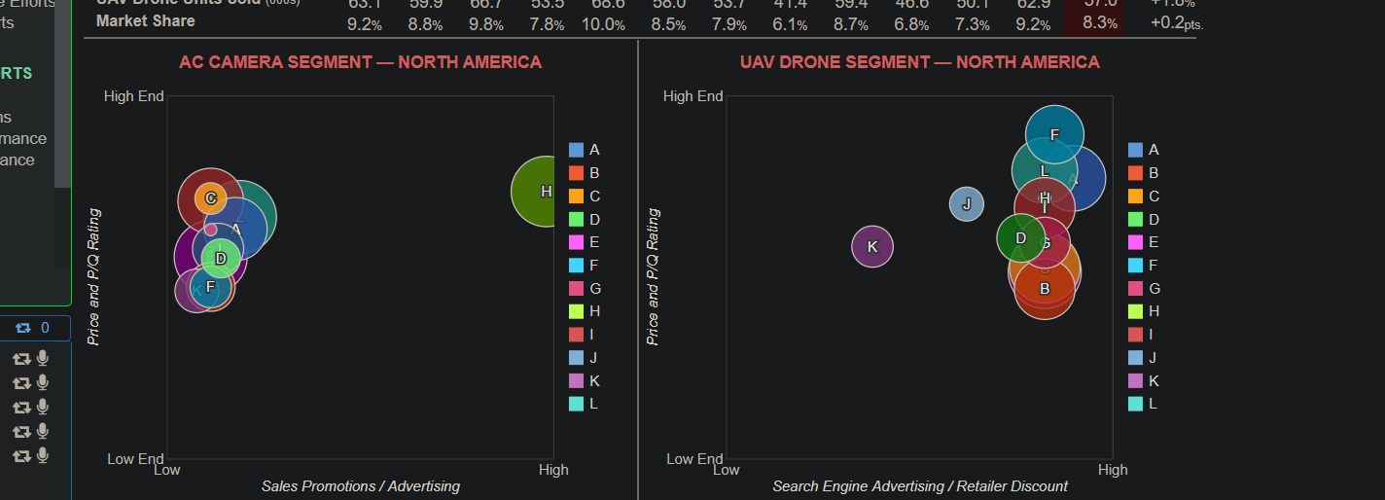

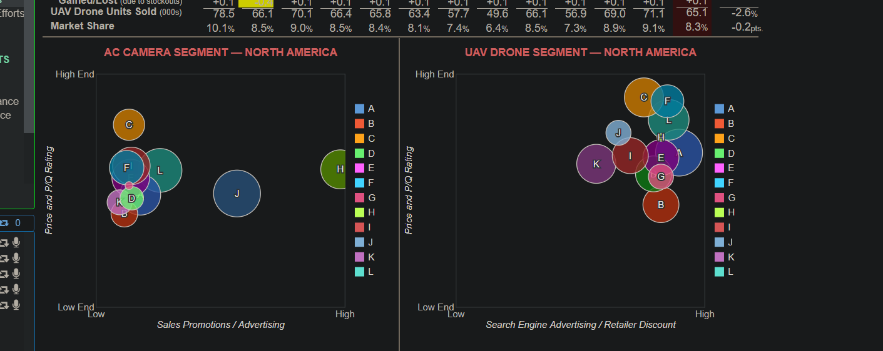

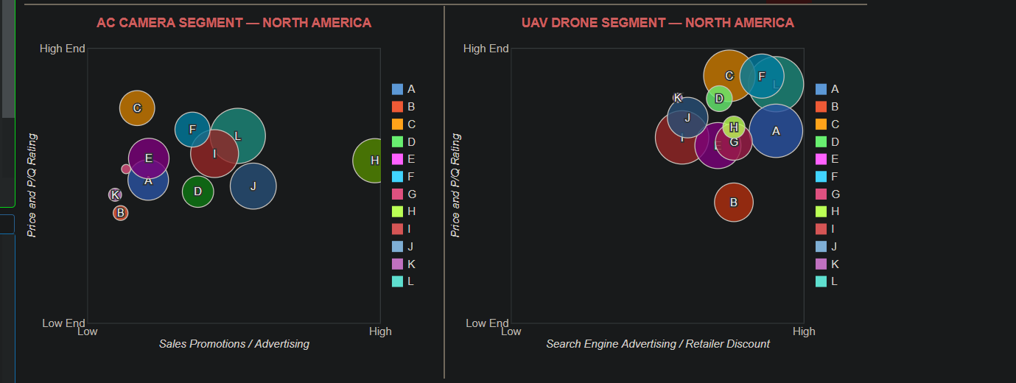

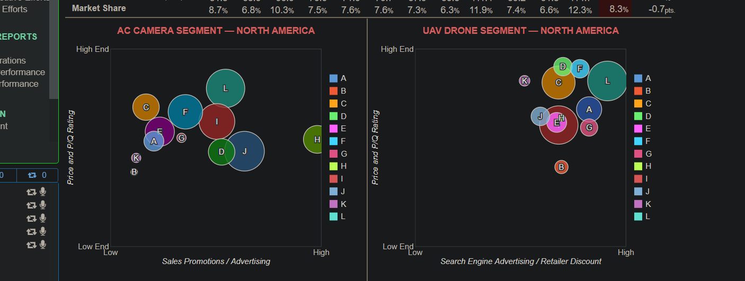

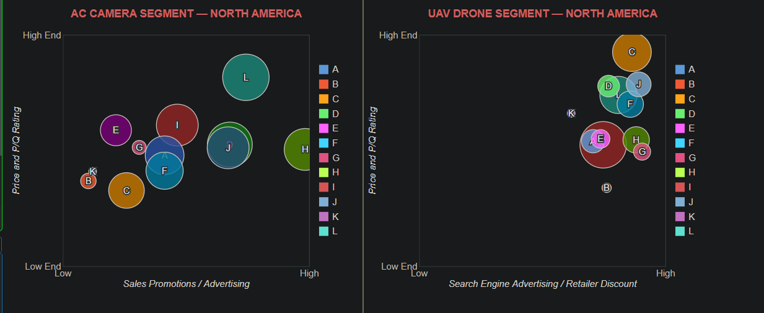

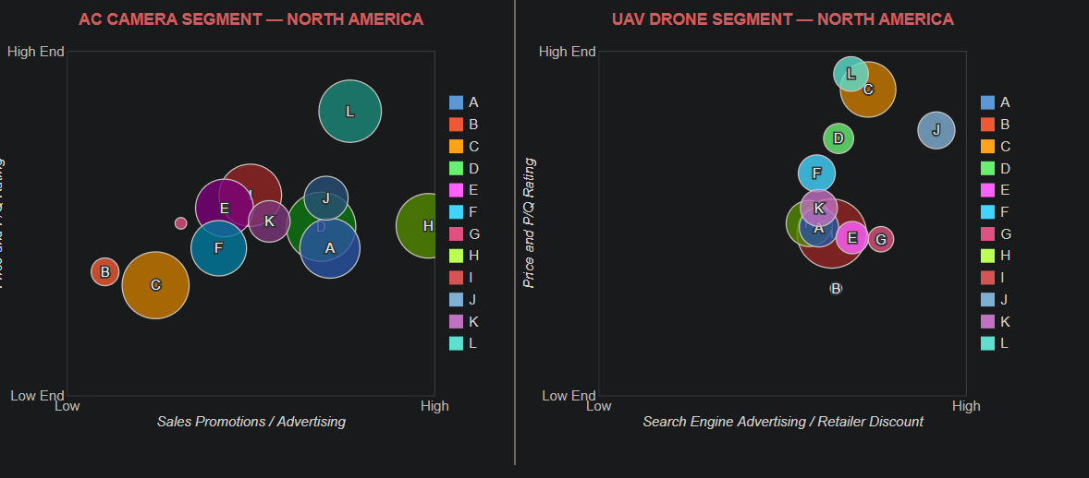

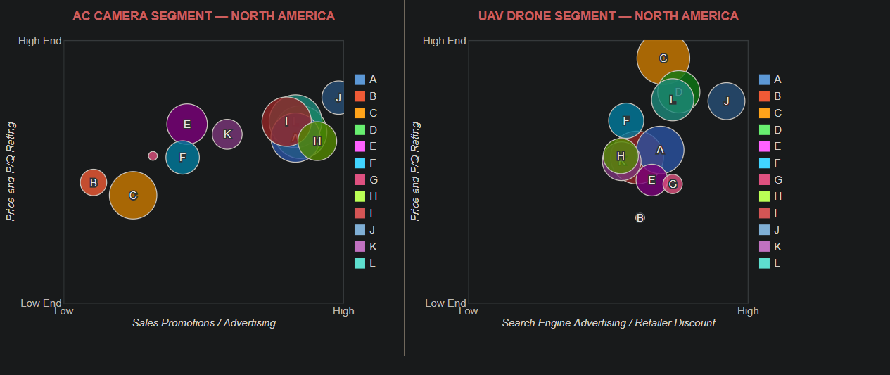

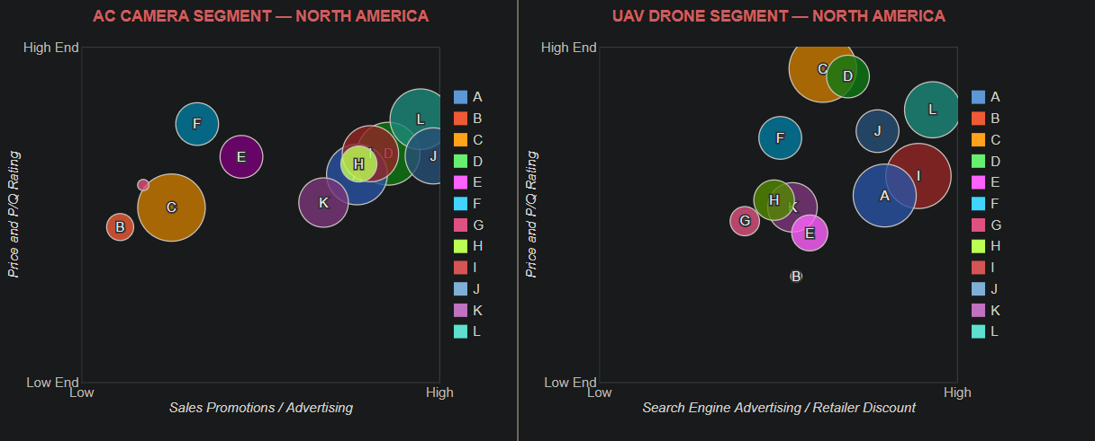

## Appendix F “Value Chain”

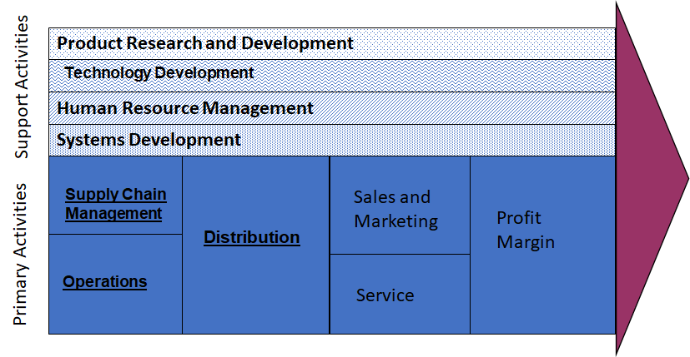

## Appendix G “Performance Analysis: Comparison with Competitors”

**Refer to the Excel file Titled Appendix G**

## Appendix H “SWOT Analysis”

|  |  |
| --- | --- |
| **STRENGTHS**   * … UAV Drone Quality * … Effective Manufacturing * … Strategic Pricing and Offers per Region in later years | **OPPORTUNITIES**   * … Increase Action Camera Marketing * … Provide More Occasional Discounts to Asia and Latin America to Penetrate the Market More |
| **WEAKNESSES**   * … Struggled to create demand in early years for our UAV drones * … Difficulty finding a price point in the earlier years to increase demand | **THREATS**   * … Cost-leadership strategies made it difficult to justify the price of our higher quality UAV Drones * … Low entry barriers allows for increased competition to enter the market |

# **REFERENCES**

**Rothaermel, F. T. (2021). *Strategic management*. New York, NY: McGraw-Hill.**

**Bus decisions & reports. (n.d.). https://www.glo-bus.com/users/program/cir/comparative-efforts**